Practical no5
Code:-
print("**** Expenses ****")

expenses = 0.0
food = 0.0
shopping = 0.0
travelling = 0.0
other = 0.0

while True:
value = float(input("Enter your amount (-1 to stop): "))
if value == -1:
break

category = input("Enter your category (food/shopping/travelling/other): ").lower()

if category == "food":
food += value
elif category == "shopping":
shopping += value
elif category == "travelling":
travelling += value
else:
other += value

# Add every expense to the total
expenses += value

print("\n=== Expenses Summary ===")
print("Food:", food)
print("Shopping:", shopping)
print("Travelling:", travelling)
print("Other:", other)
print("Total Expenses:", expenses)

Output:-
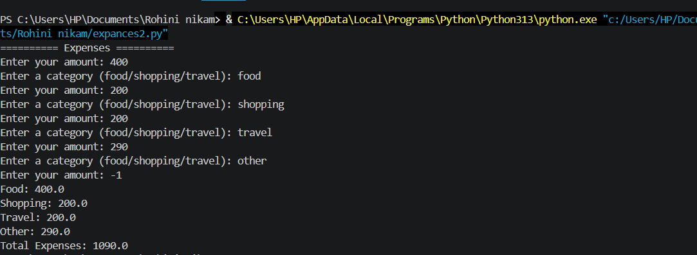

Exercises
Q1.Write a program that uses a nested loop structure to generate a right angled triangle pattern of incrementing numbers ,where each row displays its corresponding row count index.
Code:-
n = 5

# Outer loop for rows
for i in range(1, n + 1):

# Inner loop for columns
for j in range(i):
print(i, end=" ")

print()
Output:-
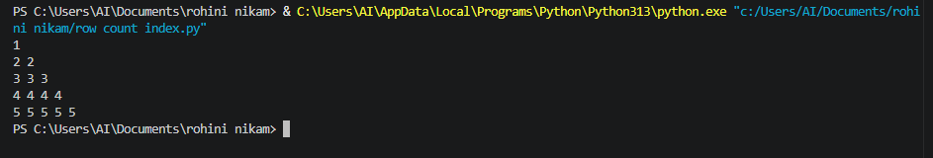

Q2.Build a script that prints a clean ,text based invoice frame border using rows and column of asterisk (*)characters.

Code:
rows = 8
columns = 30

# Nested loop for rows and columns
for i in range(rows):
for j in range(columns):
# Print * at the border
if i == 0 or i == rows - 1 or j == 0 or j == columns - 1:
print("*", end="")
else:
print(" ", end="")
print()
Output:-
